Exp:7

Date:10.04.2025

**IMPLEMENT PROGRAM FOR DECOMPOSING TIME SERIES DATA INTO TREND AND SEASONALITY.**

**AIM:** Implement program for decomposing time series data into trend and seasonality.

**PROCEDURE:**

import pandas as pd

import matplotlib.pyplot as plt

from statsmodels.tsa.seasonal import seasonal_decompose

import numpy as np

# Create a trend (increasing linearly), seasonality (weekly), and noise

trend = np.linspace(100, 200, 90)

seasonality = 10 * np.sin(2 * np.pi * days.dayofweek / 7) # Weekly seasonality

noise = np.random.normal(0, 5, 90)

# Combine them

visitors = trend + seasonality + noise

df = pd.DataFrame({'date': days, 'visitors': visitors})

df.set_index('date', inplace=True)

# Decompose the time series

result = seasonal_decompose(df['visitors'], model='additive', period=7)

# Plot the decomposition

plt.figure(figsize=(12, 9))

plt.subplot(411)

plt.plot(df['visitors'], label='Original')

plt.legend(loc='upper left')

plt.subplot(412)

plt.plot(result.trend, label='Trend')

plt.legend(loc='upper left')

plt.subplot(413)

plt.plot(result.seasonal, label='Seasonality')

plt.legend(loc='upper left')

plt.subplot(414)

plt.plot(result.resid, label='Residuals')

plt.legend(loc='upper left')

plt.tight_layout()

plt.show()

**OUTPUT:**

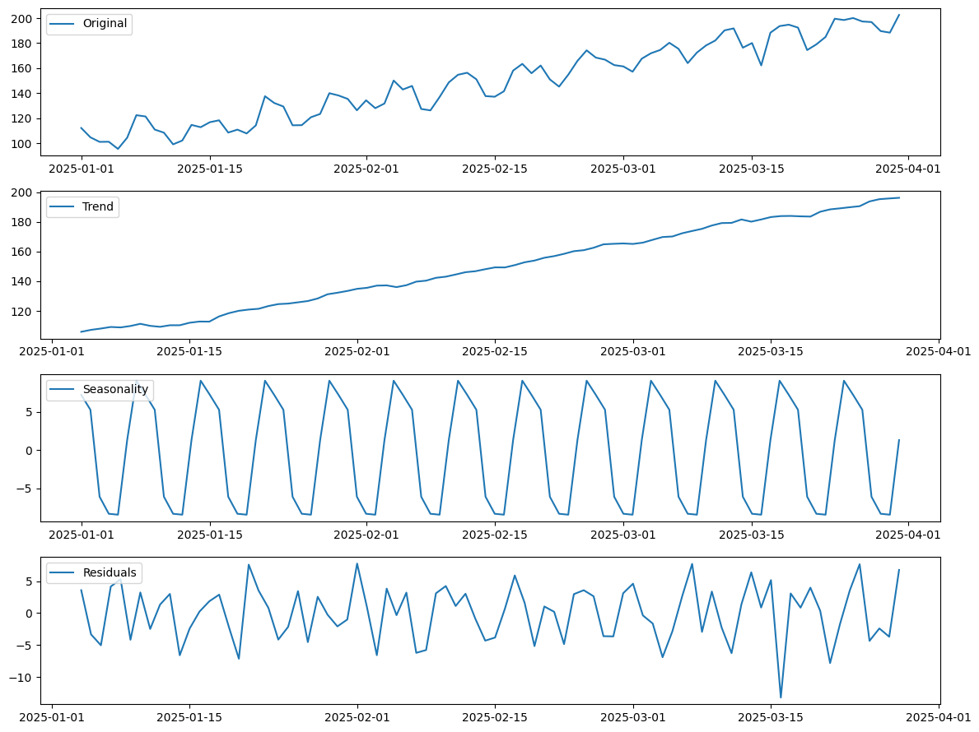

**RESULT:** Thus the expected output has been received successfully .